UNIVERSITY NAME:
COMPETITION NAME:
SHORT DESCRIPTION OF THE COMPETITION
(This will be used in marketing material so ensure you are happy for the text to be used publicly)
REPORT AUTHOR:
REPORT DATE:
UNIVERSITY
POST-COMPETITION REPORT

SECTION ONE: PRIZE WINNERS INFORMATION
FIRST PRIZE WINNER
Name of the business (or team name):
Names of all individuals in the team and course being studied (eg Biomedical Engineer, Computer Science, Electrical Engineer, Aviation Engineer):

Name of Innovation:
Description of innovation – minimum words – 100 / maximum words 250 words:
(This should clearly explain the business idea and how it solves a problem)

Amount of Engineers in Business prize money awarded to the First Prize winner:
Photos – there are three requirements for photos
- A general photo of the awards event (eg a group photo of all participants, the event in action, a poster promoting the competition). This does not need to be captioned.
- Photos of winning teams receiving their awards. If this is impossible you must provide head and shoulders photos of each winner (if there are multiple people in a team, we can create a collage of a team). The photos must be (a) colour, (b) high resolution – at least 1MB in size (photos below this size will not be accepted), (c) in focus with the subject facing the camera. Please see the final page of this document for examples of acceptable photos. Send these photos as JPEGs/PNGs as separate attachments via email or a link such as WeTransfer which is free.
- Captioning of the photos of winning teams receiving their awards - caption these photos so that the names match the line-up of the people in the photos. Include the names and titles of professional staff (eg professors, enterprise managers, sponsors etc) as well. In order to do this you will need to embed the photos in this report.
NOTE: The photos that you submit must be 1MB or larger in size, make sure your photographer is aware of this! We cannot accept photos that are smaller in size.
Mentor: Your first prize winner is entitled to request a Sainsbury Management Fellow as a mentor. If the winner wishes to do this, they must provide a short paragraph on the type of mentor they are requesting and how the mentor can help them. One mentor will be assigned for the team, not each individual.
My winner will be requesting a mentor: Yes / No (Please delete as appropriate)

SECOND PRIZE WINNER
Name of the business (or team name):
Names of all individuals in the team and course being studied (eg Biomedical Engineer, Computer Science, Electrical Engineer, Aviation Engineer):

Name of Innovation:
Description of innovation – minimum words – 100 / maximum words 250 words:
(This should clearly explain the business idea and how it solves a problem)

Amount of Engineers in Business prize money awarded to the Second Prize winner:
Photos – there are three requirements for photos
- A general photo of the awards event (eg a group photo of all participants, the event in action, a poster promoting the competition). This does not need to be captioned.
- Photos of winning teams receiving their awards. If this is impossible you must provide head and shoulders photos of each winner (if there are multiple people in a team, we can create a collage of a team). The photos must be (a) colour, (b) high resolution – at least 1MB in size (photos below this size will not be accepted), (c) in focus with the subject facing the camera. Please see the final page of this document for examples of acceptable photos. Send these photos as JPEGs/PNGs as separate attachments via email or a link such as WeTransfer which is free.
- Captioning of the photos of winning teams receiving their awards - caption these photos so that the names match the line-up of the people in the photos. Include the names and titles of professional staff (eg professors, enterprise managers, sponsors etc) as well. In order to do this you will need to embed the photos in this report.
NOTE: The photos that you submit must be 1MB or larger in size, make sure your photographer is aware of this! We cannot accept photos that are smaller in size.

THIRD PRIZE WINNER
Name of the business (or team name):
Names of all individuals in the team and course being studied (eg Biomedical Engineer, Computer Science, Electrical Engineer, Aviation Engineer):

Name of Innovation:
Description of innovation – minimum words – 100 / maximum words 250 words:
(This should clearly explain the business idea and how it solves a problem)

Amount of Engineers in Business prize money awarded to the Third Prize winner:
Photos – there are three requirements for photos
- A general photo of the awards event (eg a group photo of all participants, the event in action, a poster promoting the competition). This does not need to be captioned.
- Photos of winning teams receiving their awards. If this is impossible you must provide head and shoulders photos of each winner (if there are multiple people in a team, we can create a collage of a team). The photos must be (a) colour, (b) high resolution – at least 1MB in size (photos below this size will not be accepted), (c) in focus with the subject facing the camera. Please see the final page of this document for examples of acceptable photos. Send these photos as JPEGs/PNGs as separate attachments via email or a link such as WeTransfer which is free.
- Captioning of the photos of winning teams receiving their awards - caption these photos so that the names match the line-up of the people in the photos. Include the names and titles of professional staff (eg professors, enterprise managers, sponsors etc) as well. In order to do this you will need to embed the photos in this report.
NOTE: The photos that you submit must be 1MB or larger in size, make sure your photographer is aware of this! We cannot accept photos that are smaller in size.

If you have more than three winning teams, copy the above table into a new page and complete the details on the other winners.

SECTION TWO: YOUR PROMOTIONAL ACTIVITY
Include examples of the materials/communications produced to promote the EIB prize as part of your competition (eg lecture emails, presentations, posters, e-newsletters etc).
We do not need original photos of these items – images and screenshots can be embedded in this report.
List here links to website and media coverage that you generated on your competition and winners. If this is not relevant to your competition, please state so here.

SECTION THREE: DATA ON COMPETITION THAT HAS JUST COMPLETED
Total number of participants in the competition:
Total number of engineers (including biomedical) who took part in the competition:
Total number of computer science students who took part in the competition:
Include any other statistical information that you feel will be helpful for EIBF to know.

SECTION FOUR: COMMENT ON THE VALUE OF THE EIB PRIZE FUND
A short comment from a lead person (eg professor, enterprise professional) of the competition on the value of the Engineers in Business Prize Fund to your competition/course. Please also state to whom the quote should be accredited (Name and Position at the University)

SECTION FIVE – SURVEY ON WINNERS’ LEARNING EXPERIENCES
We would like to receive feedback from your winners on their learning experience in your competition. This will entail the team leader completing a short questionnaire. Please let us know if you can issue the questionnaire to your winner(s) and we will email you the questionnaire.
Yes / No (Please delete as appropriate)

SECTION SIX: EXAMPLES OF SUITABLE PHOTOS WITH CAPTIONS
NOTE: The photos that you submit must be 1MB or larger in size, make sure your photographer is aware of this! We cannot accept photos that are smaller in size. What makes these good: central focus on winners, all the winners in a team in one photo, animated/happy faces, university branding, high resolution. A good photo is accompanied by a caption naming the people in the photo in the order they appear. Not providing the right type of photos and captioning will delay payment of the prize fund.
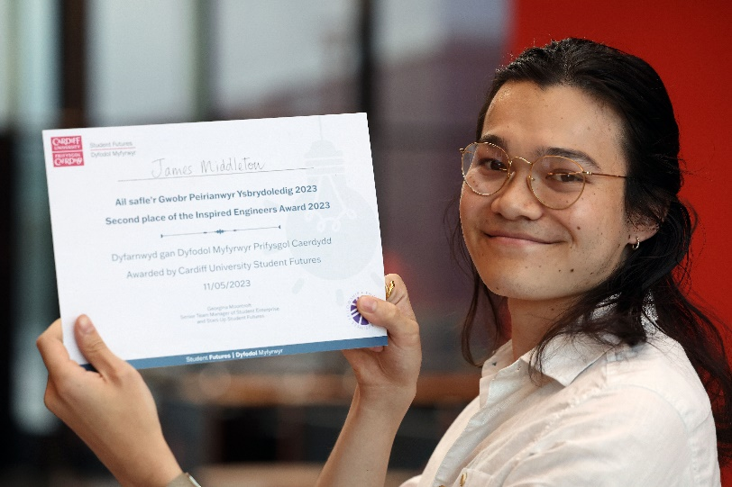
James Middleton

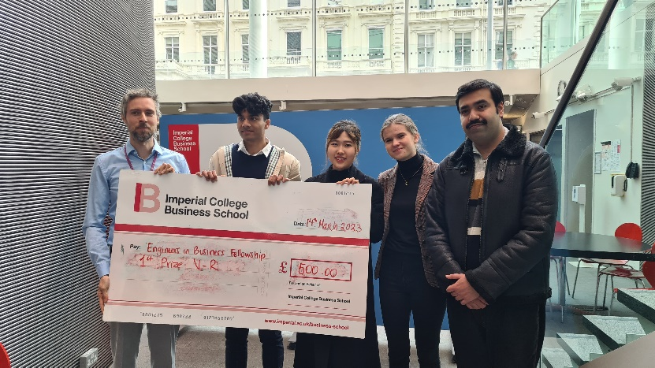
Left to right are Tim Wiess, Module Leader with the VR Team members Tarun Bhaskaran, Jiaying Pan,
Izabella Kacprzak and Ali Gill

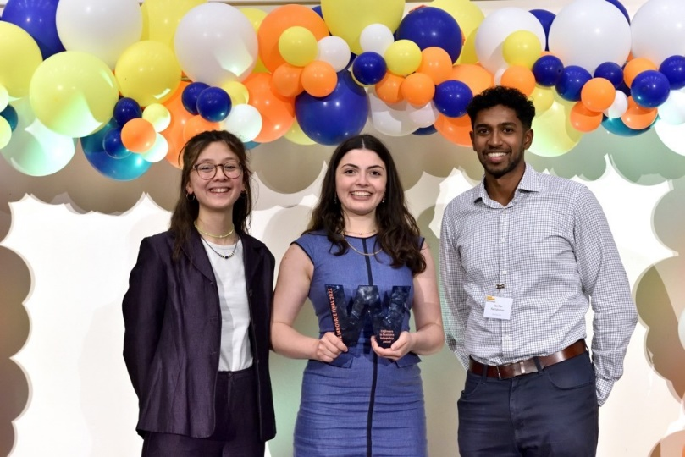
Left to right are Anais Engelmann and Megan Hale with Sainsbury Management Fellow Jayshan Ratnakumar,
Co-Founder @Stance. Team Repair consists of three other team members, Oscar Jones, Oliver Colebourne and Patrick McGuckian (not pictured).

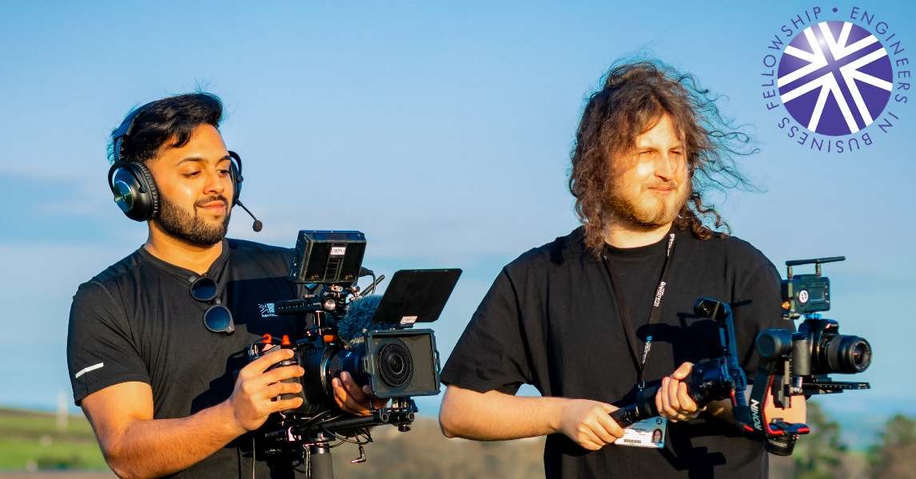
Left to right are Raex Philip and Callum Payn.

If you need any assistance to complete this form email eibcompetition@eibc.org.uk

